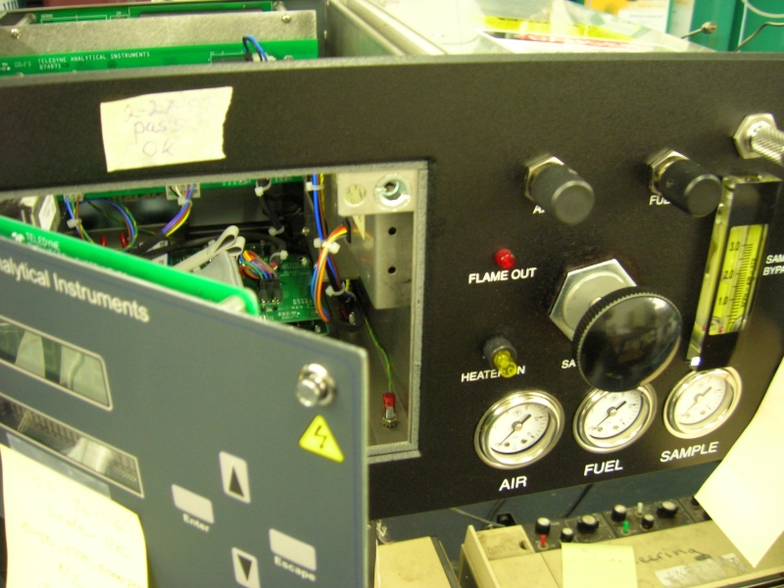
Location of the potentiometer.
Location of test point on
PCB P/N B74674

1- Introduce zero gas to the analyzer and let it run for 15 minutes.
2- Then connect the voltmeter negative to TP1 and positive to TP2
3- Adjust the pot so that the DMM read <10mv.\
4- Zero calibrate
5- Span calibrate.

