Application Bulletin: UV Lamp Life Extension Tips
TAI uses a low pressure zinc vapor lamp as the UV source for photo-excitation in the 6200 series UV Fluorescence Analyzers. This Application Bulletin describes some tips for extending the life of the UV lamp.
There are several factors influencing the lamp lifetime:
- Lamp sheath integrity
- Correct lamp current
- Lamp position

Lamp Sheath
The low pressure zinc lamp uses an outer glass (fused silica) sheath as a vacuum jacket around the dual bore bulb. It is designed to act as a thermal barrier to help keep the bulb at a proper vaporization temperature. The sheath gets hot during use. Any grease or oil on the glasss will cause affected areas of the glass to undergo a microstructural change that degrades the optical transmission of the sheath glass.
- The most common source of contamination is from handling the glass sheath with bare fingers. Always use latex gloves when handling the lamp or lamp assembly.
- Clean any fingerprints or grease on the sheath using methanol and a lint-free paper or cloth.

Lamp Current
The user should also make sure that the proper current is going to the lamp. For the 6200E, 6400E or 6400EH family ONLY ( E series analyzers), this can be verified by looking at the UV lamp driver board to make sure it has a yellow dot in the upper left hand corner. TAI P/N 051120100 for the 6200E, 6400E or 6400EH family ONLY ( E series analyzers). If there is a red dot or no dot at all on the board, then the lamp is NOT receiving the correct current and will likely fail prematurely. This does not apply to the A series analyzers since these units power the UV lamp from the UV Transformer.
- Check for a yellow dot on UV Lamp driver PCB (E-series analyzers only).
- Periodically run the lamp calibration routine followed by a Factory Calibration as specified in the Instruction Manual.

Lamp Position
The light intensity is not uniform along the length of the UV lamp. The lamp can be rotated and/or moved up and down within its housing. See Figures 1 and 2.
- Press TST repeatedly until UV LAMP=XXXX.X appears on the display. Note the lamp output.

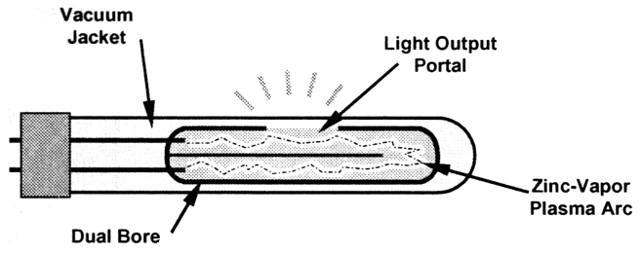

Figure 1: UV Lamp Structure

- If the lamp output has decreased, rotate the lamp or move it up and down in the holder to obtain the maximum energy. See the Instruction Manual for procedures.
- Adjust VR1 on the detector board for 4000mv or the maximum obtainable voltage. The lamp will operate between 600 and 4900mv. If the output is below 600mV, replace the lamp. Refer to Figure 3 for sensor assembly diagram.
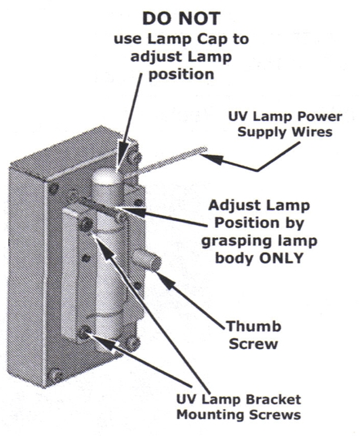
Figure 2: Adjusting the UV Lamp Position
Figure 3: Sensor Assembly

Lamp Drift
It is possible to improve the analyzers response to lamp drift for the Model 6200 A and E Series of analyzers using the software.although this will not extend the lamp life. To do this:
- Enter the lamp_gain function available in the Service Menus by pressing: [setup/-more/vars/ then enter “929”/ password/next . . .next/ lamp_gain.
- The lamp_gain is set at the factory to .9. Increase the lamp gain value to 1.0.

