Application Bulletin: End of Life Determination for Trace Analysis Micro Fuel Cells

This Application Bulletin describes the typical indicators that signify the need to replace the micro fuel cell in Teledyne’s Trace O₂ Analyzers. Specifically, it covers the following sensors: B2C, B2C-Xl, Insta Tracer, Insta Trace XL, L2C, and L2CXL sensors.
These sensors are used in Teledyne Analyzers such as the 3000TA, 3000TAXL, 3020TA, 3020TAXL, Insta Trans, and other similar analyzers or variants of these models.
Typically these analyzers are used to measure low concentrations of O₂ below the 10 ppm level and at levels that are usually fairly constant. For instance, a Teledyne Trace Oxygen Analyzer might be used in a application involving the cryogenic production of N₂. In this industrial process where pure N₂ is produced with a more or less constant O₂ impurity level hovering around 0.5ppm, the analyzer must continuously produce a reading and output signal of this magnitude with minimal drift and noise.
When the micro fuel cell has been in service for many months or years, at some point near the end of the cell’s lifetime, chemical changes occur in the sensor. These changes suddenly drive the output of the sensor to a higher steady state level for the same O₂ concentration it has been measuring. The most noticeable effect is an increase in the zero offset of the sensor, i.e. the sensor output signal increases in a pure (zero) gas environment. This is shown in Figures 1 through 4 for two different B2C sensors.
This is typical behavior indicating the MFC’s end of service life. It is a very repeatable and consistent effect. Teledyne recommends that once the onset of zero offset increase is noticed users should replace the micro fuel cell as soon as possible.
Figure 1: Onset of Zero Offset Increase
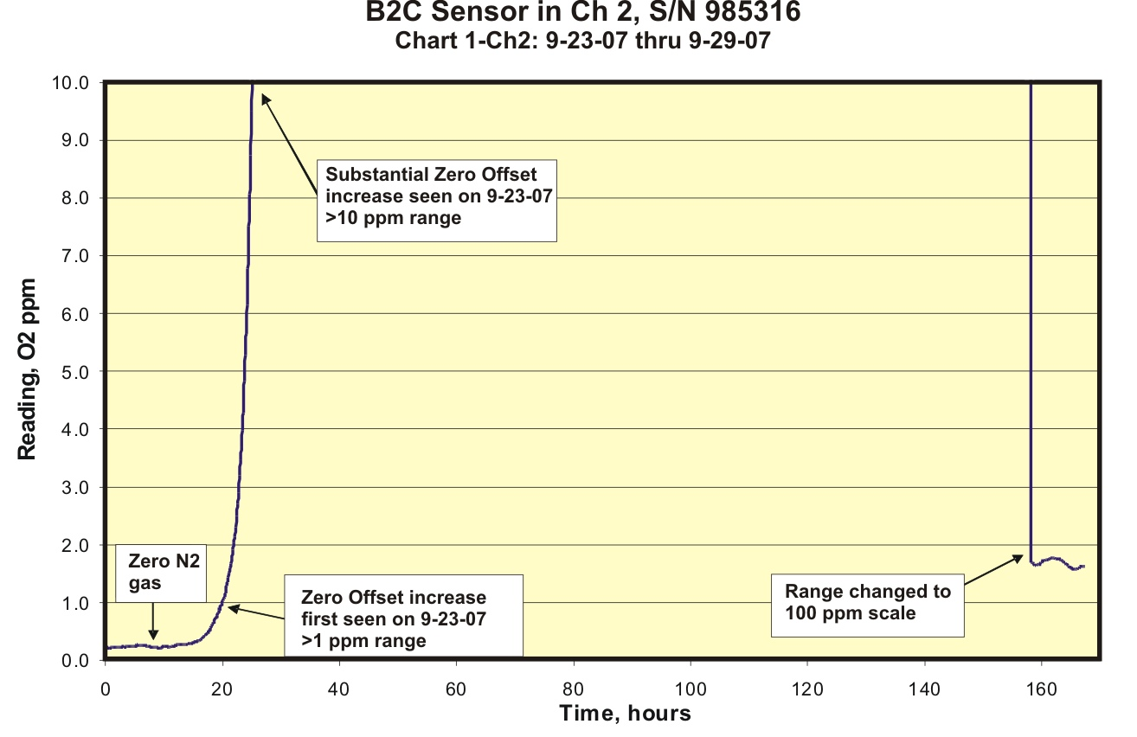

Figure2: A Closer Look at the Onset of Zero Offset Change
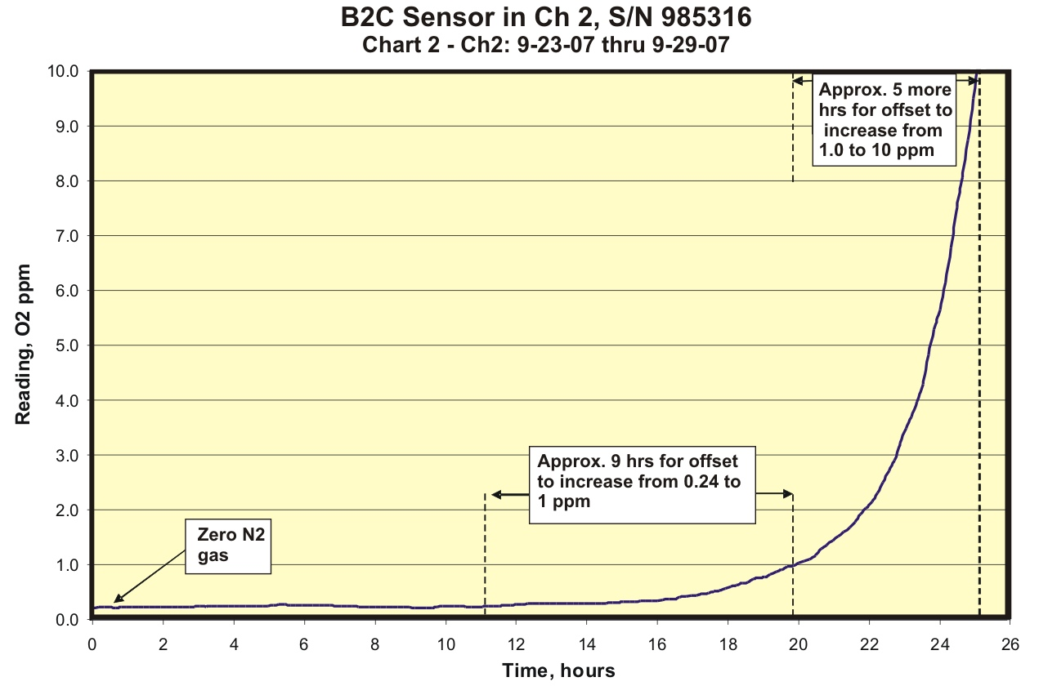
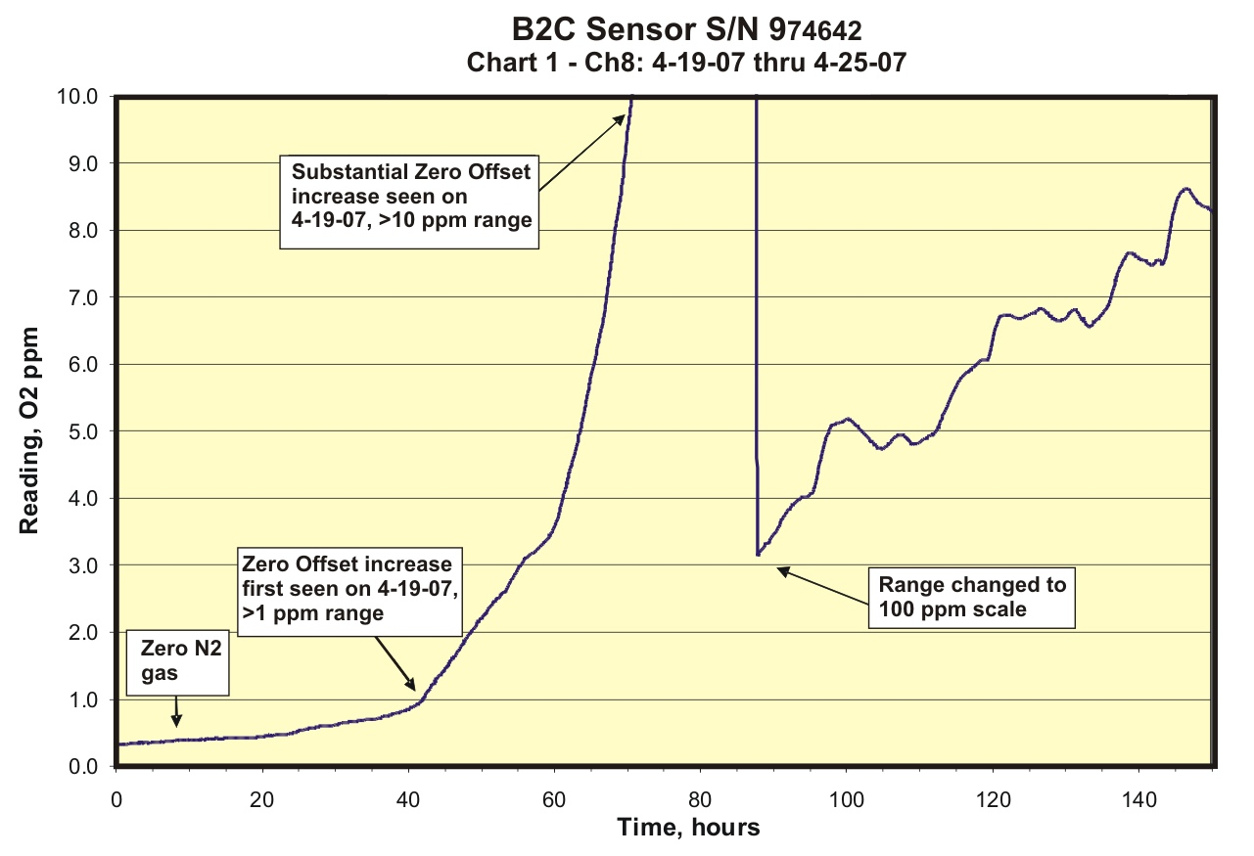
Figure 3: Different Sensor Showing Similar Zero Offset Behavior at End of Sensor Life

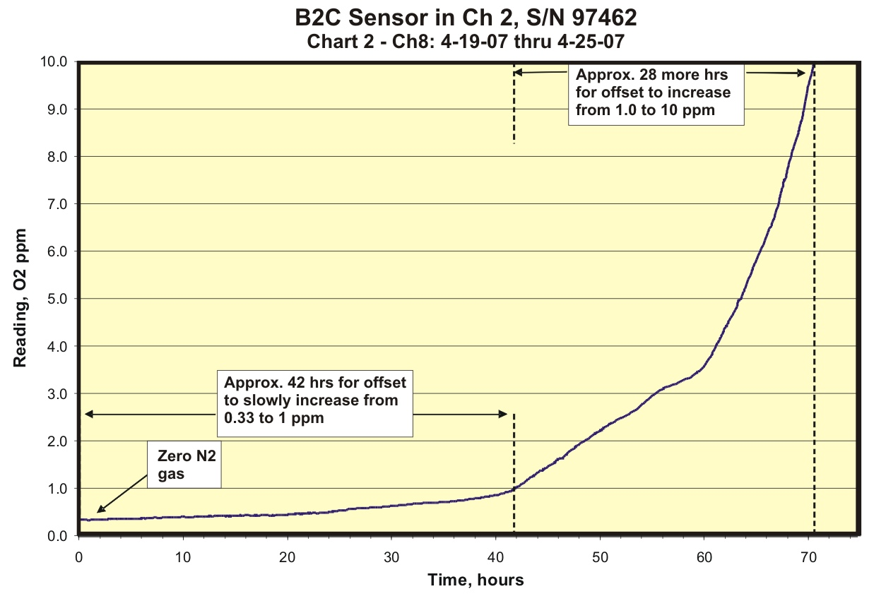
Figure 4: A Closer Look at the Onset of Zero Offset Change for Sensor 97462

Direct any firther inquires to Teledyne Customer Service Department via email at TETCI_customerservice@teledyne.com Please include the following details in your email:
- Full name of the person placing the request
- Complete legal name of the company (No acronyms)
- Telephone and fax number with area code (country code for international numbers)
- Company street address, city, state and country
- Model number and serial number of the Teledyne product
- Brief explanation of technical support request
- Advise product application or end-use

