16830 CHESTNUT STREET, CITY OF INDUSTRY, CA 91748-1020

P.O. BOX 1580, CITY OF INDUSTRY, CA 91749-1580

TELEPHONE: (626) 934-1500 OR (626) 961-9221

FAX: (626) 961-2538 OR (626) 934-1651

WEB SITE: www.teledyne-ai.com

Instructions to Starting Educted System

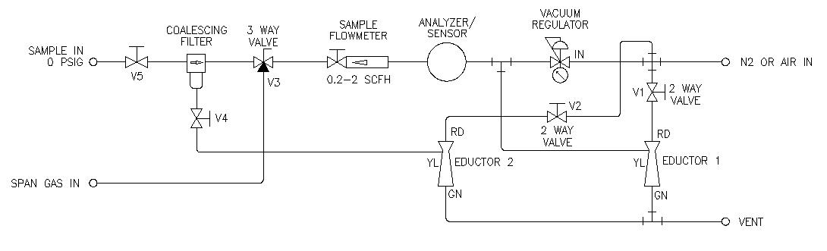

1. Close all valves and gas connections.

2. Apply Air or Nitrogen to the inlet for the eductors at a pressure of 5-20 psig (5 psig should be sufficient).

3. Open valve V5.

4. Apply sample gas by switching valve V3 to SAMPLE. If the sample gas cannot be applied, ambient air being drawn into the system should be sufficient for setting pressure and flow rates.

5. Open the drain valve on the coalescing filter (V4) slightly.

6. Open the flow valve for Eductor 2 (V2) to create suction on the drain loop. This suction need only be high enough so that any coalesced materials will actually drain out of the filter.

7. Open the Sample Flowmeter valve completely.

8. Open the flow valve for Eductor 1 (V1) slightly to create a vacuum on the sample path.

9. Set the Vacuum Regulator to approximately - 2 psig (-100 mmHg), or a 2 psig (100 mmHg) vacuum. Valve V1 may also need to be adjusted (if applicable) to achieve a constant pressure.

10. Adjust the Sample Flowmeter valve so that flow rate on the flowmeter reads mid-scale.

Calibration

NOTE: if the analyzer requires a zero calibration, perform the steps below for zero before proceeding to span calibration. Otherwise, perform only the steps below.

11. Span gas connection should be equipped with regulator capable of supplying nominal 5 psig pressure and needle valve for flow control.

12. Apply span gas by switching valve V3 to SPAN.

13. Confirm settings per Steps 2 and 3.

14. Open the needle valve on the span bottle and adjust so that flow on the Sample Flowmeter reads mid-scale – DO NOT ADJUST FLOW FROM THE SAMPLE FLOWMETER VALVE.

15. Perform calibration per analyzer procedure.

16. Switch back to SAMPLE on valve V3.

R. Milversted
4/14/2008

